Finding lower/ upper / digit / space / special char.
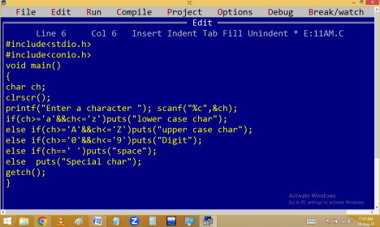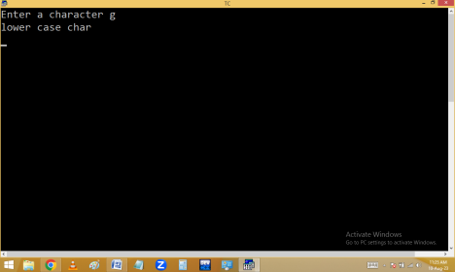
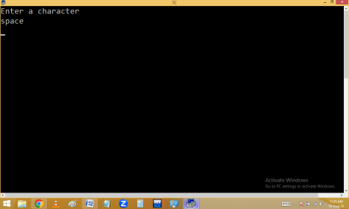Using ascii values:
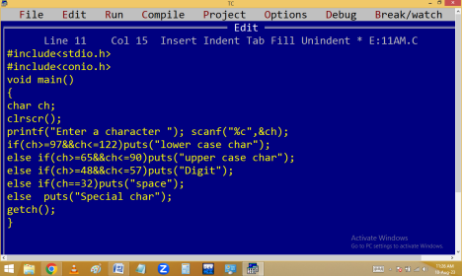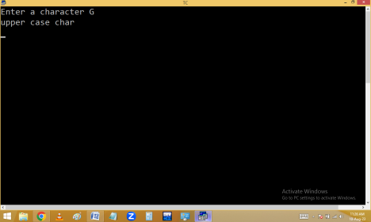
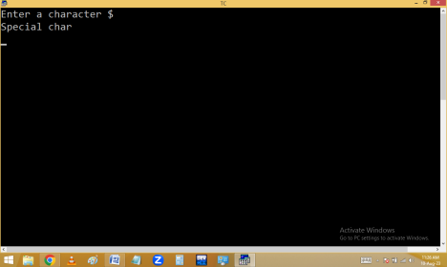Using predefined functions:
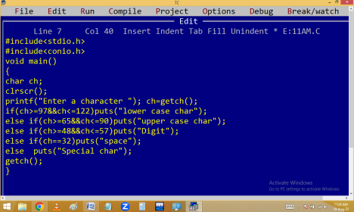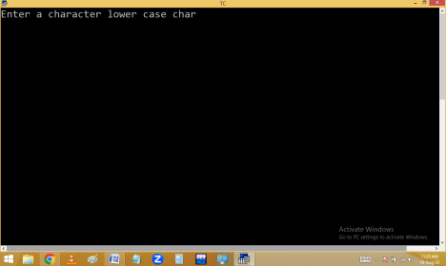
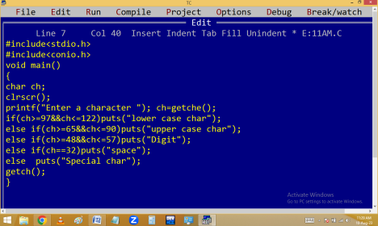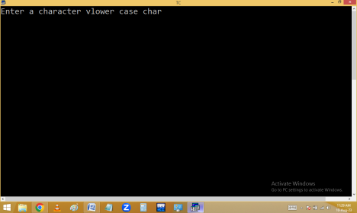
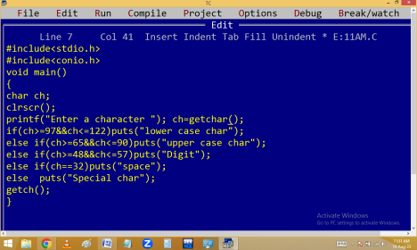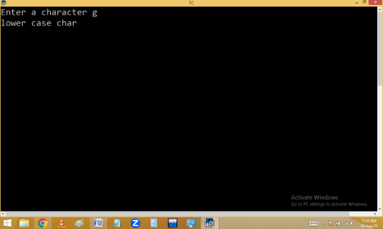
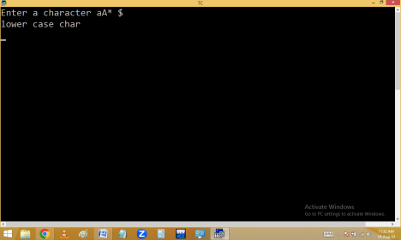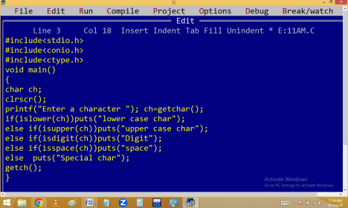
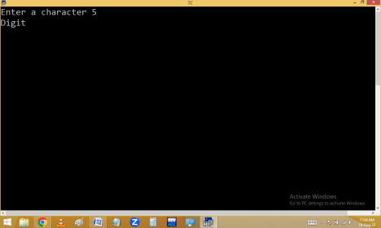
getch() | getche() | getchar()
Reads single char | Reads single char | Reads single char

Entered char is not visible | char is visible | char is visible
Not waiting for  enter key | Not waiting for  enter key | Waiting for enter key
Belongs to conio.h | Belongs to conio.h | Belongs to stdio.h
char not changeable char not | changeable | char changeable

Note: All the above functions returns ASCII value(int) of reading character.
isupper(), islower(), isdigit(), isspace():
They are used to check the given character is upper / lower/ digit / space.
tolower(), toupper(): They are used to convert the character from upper case to lower and lower to upper.
All these functions / macros available in <ctype.h> Lower to upper / upper to lower conversion:
Without predefined:
Eg. Finding person stage.
1-2 – baby
3-7 – kid
8-12 – child
13-18 – teenage
19-45 – adult
46 – 59 – middle aged
>59 – senior citizen
If within if is called nested if.
ATM PIN Validation:
IRCTC Login:
Gmail style login:
Net Banking Style Login:

